Exercise: StorageKubernetes is a free and open-source container orchestration platform. It provides services and management capabilities needed to efficiently deploy, operate, and scale containers in a cloud or cluster environment.  
When managing containerized environments, Kubernetes storage is useful for storage administrators, because it allows them to maintain multiple forms of persistent and non-persistent data in a Kubernetes cluster. This makes it possible to create dynamic storage resources that can serve different types of applications.

Practice 1: Direct provisioning of Azure File storage  
1. Login to Azure and connect to your AKS cluster.  
2. Check if any pods run under the default namespace if so delete everything under the default namespace.

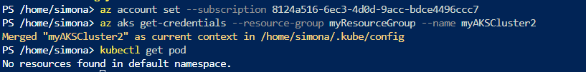  
3. In this practice we will directly provision Azure Files to a pod running inside AKS.  
4. First create the Azure Files share. Run the following commands:  
# Change these four parameters as needed for your own environment  
AKS_PERS_STORAGE_ACCOUNT_NAME=mystorageaccount$RANDOM  
AKS_PERS_RESOURCE_GROUP=myAKSShare  
AKS_PERS_LOCATION=eastus  
AKS_PERS_SHARE_NAME=aksshare



# Create a resource group  
az group create --name $AKS_PERS_RESOURCE_GROUP --location $AKS_PERS_LOCATION

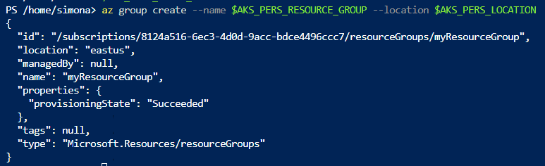

# Create a storage account  
az storage account create -n $AKS_PERS_STORAGE_ACCOUNT_NAME -g $AKS_PERS_RESOURCE_GROUP -l  
$AKS_PERS_LOCATION --sku Standard_LRS

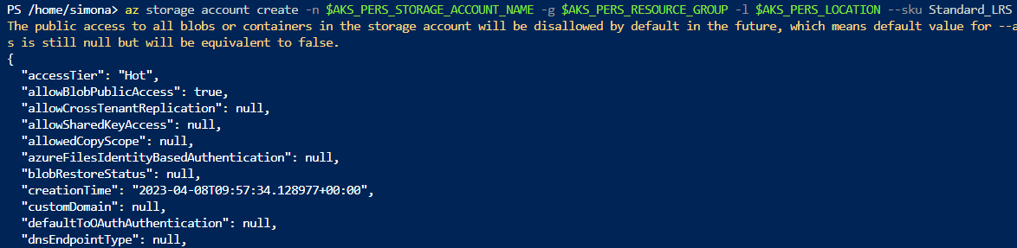  
# Export the connection string as an environment variable, this is used when creating the Azure file share  
export AZURE_STORAGE_CONNECTION_STRING=$(az storage account show-connection-string -n  
$AKS_PERS_STORAGE_ACCOUNT_NAME -g $AKS_PERS_RESOURCE_GROUP -o tsv)



# Create the file share  
az storage share create -n $AKS_PERS_SHARE_NAME --connection-string  
$AZURE_STORAGE_CONNECTION_STRING

  
# Get storage account key  
$STORAGE_KEY=$(az storage account keys list --resource-group $AKS_PERS_RESOURCE_GROUP --account-name  
$AKS_PERS_STORAGE_ACCOUNT_NAME --query "[0].value" -o tsv)

  
# Echo storage account name and key  
echo Storage account name: $AKS_PERS_STORAGE_ACCOUNT_NAME  
echo Storage account key: $STORAGE_KEY  
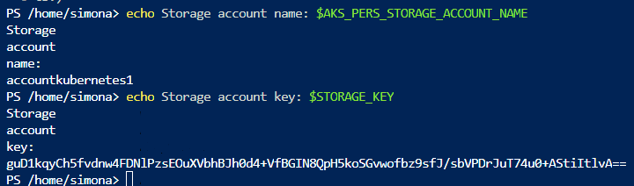  
5. Make a note of the storage account name and key shown at the end of the script output. These values are needed when you create the Kubernetes volume in one of the following steps.

6. Now we will need to create a Kubernetes secret that will be used to mount the Az File Share to the pod. You need to hide this information from the pod’s definition and K8S secret is the best way to do it.

7. Run the following (single) command to create the secret:  
kubectl create secret generic azure-secret --from- \literal=azurestorageaccountname=$AKS_PERS_STORAGE_ACCOUNT_NAME \--from-literal=azurestorageaccountkey=$STORAGE_KEY

****8. Check if secret was created. Run kubectl get secret -A.

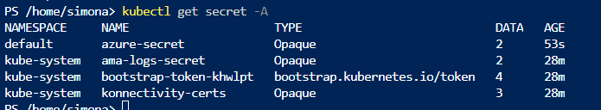  
9. Now we can create the pod and mount the Azure File. Create a new file named azure-files-pod.yaml with the following contents:

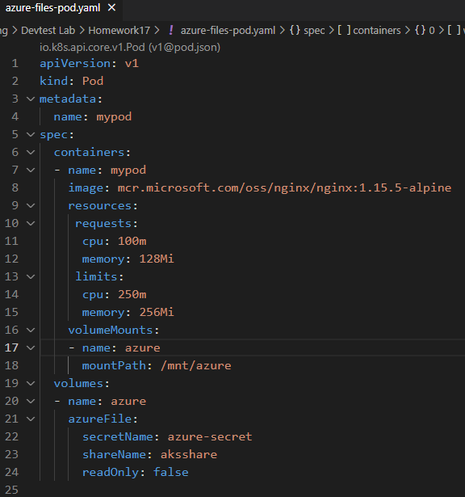

This file is uploaded in Azure  
10. Run kubectl apply -f azure-files-pod.yaml.

  
11. You now have a running pod with an Azure Files share mounted at /mnt/azure.  
12. You can use kubectl describe pod mypod to verify the share is mounted successfully. Search for the Volumes section of the output.

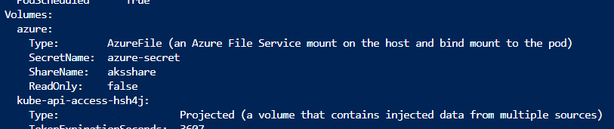  
13. Now exec to the pod and try to access the mounted file share. Run the following command kubectl exec –itmypod – bash

**kubectl exec -it mypod -- sh**14. Go to /mnt/azure and create a blank file test.txt file.  
15. Go to the portal and locate your Azure storage provisioned for this practice.  
16. Under the Files section, check the contents of the Azure file share and check if test.txt file exists.  
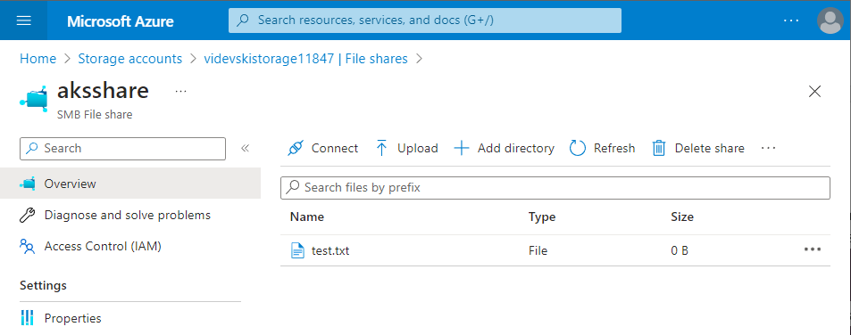  
17. Delete the mypod. What happens to the Azure File share?



The file remains in the storage

Practice 2: Provisioning Azure File storage using PVs and PVCs  
1. Login to Azure and connect to your AKS cluster.  
2. Check if any pods run under the default namespace if so delete everything under the default namespace.  
3. Now we will provision Azure files storage to a pod using PV and PVC.  
4. Create a azurefile-mount-options-pv.yaml file with a PersistentVolume like this:  
apiVersion: v1   
kind: PersistentVolume  
metadata:  
name: azurefile  
spec:  
capacity:  
storage: 5Gi  
accessModes:  
- ReadWriteMany  
azureFile:  
secretName: azure-secret  
shareName: aksshare  
readOnly: false  
mountOptions:  
- dir_mode=0777  
- file_mode=0777  
- uid=1000  
- gid=1000  
- mfsymlinks  
- nobrl  
5. Note the access mode. Can you use other mode with Azure files?

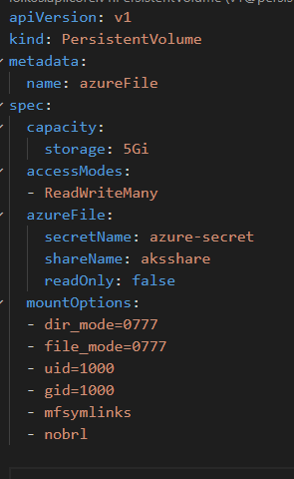

ReadWriteOnce , ReadOnlyMany , ReadWriteMany

6. Now create a azurefile-mount-options-pvc.yaml file with a PersistentVolumeClaim that uses the PersistentVolume like this:  
apiVersion: v1   
kind: PersistentVolumeClaim   
metadata:  
name: azurefile  
spec:  
accessModes:  
- ReadWriteMany  
storageClassName: ""  
resources:  
requests:  
storage: 5Gi  
  
7. Execute kubectl apply -f azurefile-mount-options-pv.yaml and kubectl apply -f azurefile-mount-optionspvc.yaml.

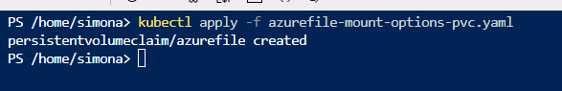  
8. Verify your PersistentVolumeClaim is created and bound to the PersistentVolume. Run kubectl get pvcazurefile.

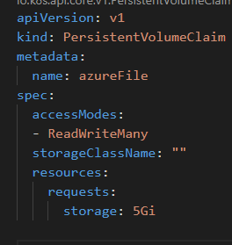

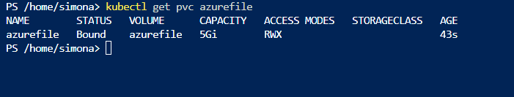

9. Now we can embed the PVC info inside our pod definition. Create the following file azure-files-pod.yaml with following content:  
apiVersion: v1  
kind: Pod  
metadata:  
name: mypod  
spec:  
containers:  
- image: mcr.microsoft.com/oss/nginx/nginx:1.15.5-alpine  
name: mypod  
resources:  
requests:  
cpu: 100m  
memory: 128Mi  
limits:  
cpu: 250m  
memory: 256Mi  
volumeMounts:  
- name: azure  
mountPath: /mnt/azure  
volumes:  
- name: azure  
persistentVolumeClaim:  
claimName: azurefile

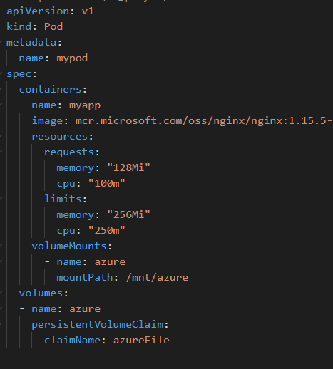  
10. Run kubectl apply -f azure-files-pod.yaml.  
11. You now have a running pod with an Azure Files share mounted at /mnt/azure.  
12. You can use kubectl describe pod mypod to verify the share is mounted successfully. Search for the Volumes section of the output.  
13. Now exec to the pod and try to access the mounted file share. Run the following command kubectl exec –itmypod -- bash14. Go to /mnt/azure and create a blank file test.txt file.  
15. Go to the portal and locate your Azure storage provisioned for this practice.  
16. Under the Files section, check the contents of the Azure file share and check if test.txt file exists.  
17. Delete the mypod the pv and pvc you have created so far. What happens to the Azure File share?

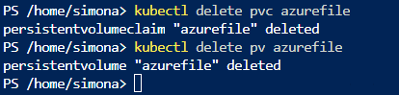

the files are still in the File Share

Practice 3: Provisioning Azure file storage using Storage Classes  
1. Login to Azure and connect to your AKS cluster.  
2. Check if any pods run under the default namespace if so delete everything under the default namespace.

It is the same as in Task 1  
3. Now we will provision file storage using the definition of storage classes. Create a file named azure-file-sc.yaml and copy in the following example manifest:  
kind: StorageClass  
apiVersion: storage.k8s.io/v1  
metadata:  
name: my-azurefile  
provisioner: kubernetes.io/azure-file  
mountOptions:  
- dir_mode=0777  
- file_mode=0777  
- uid=0  
- gid=0  
- mfsymlinks  
- cache=strict  
- actimeo=30  
parameters:  
skuName: Standard_LRS  
4. Create the storage class with kubectl apply -f azure-file-sc.yaml .

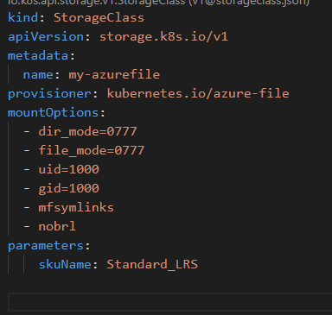

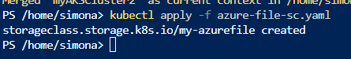

5. Now we will create the PVC that will consume the storage class defined previously. Create a file named azurefile-pvc.yaml and copy in the following YAML:  
apiVersion: v1  
kind: PersistentVolumeClaim  
metadata:  
name: my-azurefile  
spec:  
accessModes:  
- ReadWriteMany  
storageClassName: my-azurefile  
resources:  
requests:  
storage: 5Gi  
6. Create the persistent volume claim with the kubectl apply -f azure-file-pvc.yaml.

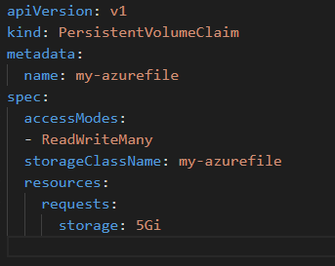

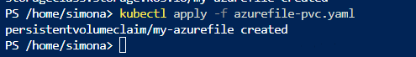  
7. Once completed, the file share will be created. A Kubernetes secret is also created that includes connection information and credentials. You can use the kubectl get pvc my-azurefile command to view the status of the PVC.

  
8. Now we will create the pod that consumes the PVC. Create a file named azure-pvc-files.yaml, and copy in the following YAML. Make sure that the claimName matches the PVC created in the last step:  
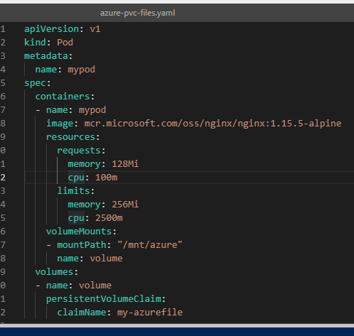  
9. Create the pod with kubectl apply -f azure-pvc-files.yaml .



10. Do a describe on the pod and check the volumes mounted.

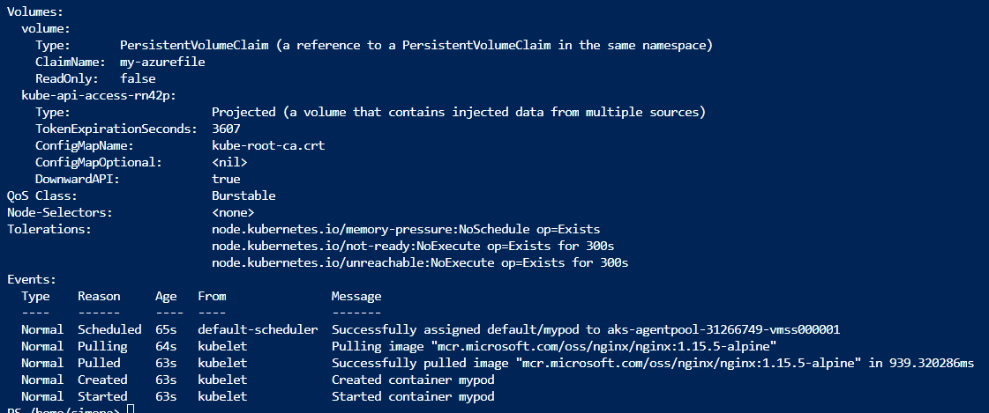

11. Delete everything created under this practice including the storage class.

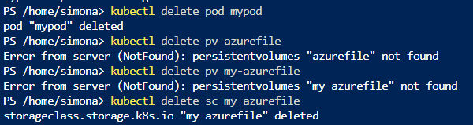

Practice 4: Direct provisioning of Azure Disk storage  
1. Login to Azure and connect to your AKS cluster.  
2. Check if any pods run under the default namespace if so delete everything under the default namespace.  
3. In this practice we will directly provision Azure Disk to a pod running inside AKS.  
4. First create the disk in the node resource group. First, get the node resource group name with az aks show --resource-group myResourceGroup --name myAKSCluster --query nodeResourceGroup -o tsv .



5. Now create a disk using:  
az disk create \  
--resource-group MC_myResourceGroup_myAKSCluster_eastus \  
--name myAKSDisk \  
--size-gb 20 \  
--query id --output tsv

az disk create --resource-group MC_myResourceGroup_myAKSCluster_eastus --name myAKSDisk --size-gb 20 --query id --output tsv

  
  
6. Make a note of the disk resource ID shown at the end of the script output. This value is needed when you create the Kubernetes volume in one of the following steps.

/subscriptions/8124a516-6ec3-4d0d-9acc-bdce4496ccc7/resourceGroups/MC_myResourceGroup_myAKSCluster2_eastus/providers/Microsoft.Compute/disks/myAKSDisk

7. Now we can create the pod and mount the Azure Disk. Create a new file named azure-disk-pod.yaml with the following contents:  
apiVersion: v1  
kind: Pod  
metadata:  
name: mypod  
spec:  
containers:  
- image: mcr.microsoft.com/oss/nginx/nginx:1.15.5-alpine  
name: mypod  
resources:  
requests:  
cpu: 100m  
memory: 128Mi  
limits:  
cpu: 250m  
memory: 256Mi  
volumeMounts:  
- name: azure  
mountPath: /mnt/azure  
volumes:  
- name: azure  
azureDisk:  
kind: Managed  
diskName: myAKSDisk  
diskURI: <!!!!!!!!!!!!! Put the Disk resource id noted before!!!>

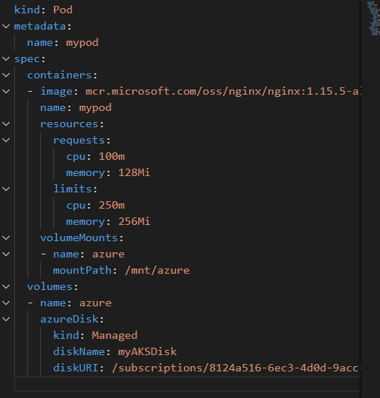  
8. Run kubectl apply -f azure-disk-pod.yaml.

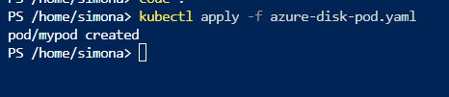  
9. You now have a running pod with an Azure Disk mounted at /mnt/azure.  
10. You can use kubectl describe pod mypod to verify the share is mounted successfully. Search for the Volumes section of the output.

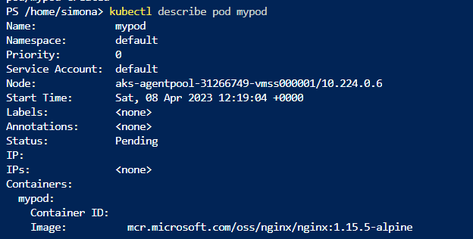

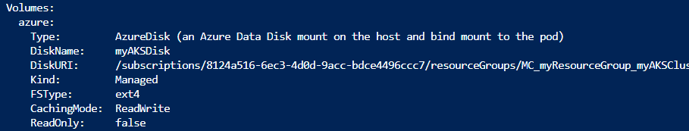  
11. Now exec to the pod and try to access the mounted volume. Run the following command kubectl exec -itmypod – bash



The status was: container creating so I assume it takes time to be created12. Go to /mnt/azure and try create a blank file test.txt file.  
13. Delete everything created by this practice.

Practice 5: Provisioning Azure Disk storage using Storage Classes1. Login to Azure and connect to your AKS cluster.  
2. Check if any pods run under the default namespace if so delete everything under the default namespace.

  
3. Now we will provision Azure disk and attach it to a running pod but this time using dynamic provisioning with storage classes. List the available storage classes, run kubectl get sc.

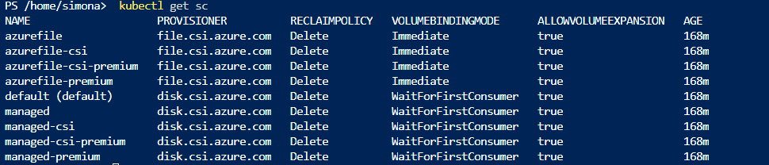4. Examine the output. Each AKS cluster includes four pre-created storage classes, two of them configured to work with Azure disks, default and managed-premium. We will use the managed-premium in our PVC definition since it uses premium type of disks.  
5. Now we will create the PVC that will consume the storage class defined previously. Create a file named azurepremium.yaml and copy in the following YAML:  
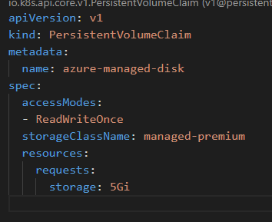  
6. Create the persistent volume claim with the kubectl apply -f azure-premium.yaml.

****7. Check the status of your PVC.

  
8. Now we will create the pod that consumes the PVC. Create a file named azure-pvc-disk.yaml, and copy in the following YAML. Make sure that the claimName matches the PVC created in the last step:  
kind: Pod  
apiVersion: v1  
metadata:  
name: mypod  
spec:  
containers:  
- name: mypod  
image: mcr.microsoft.com/oss/nginx/nginx:1.15.5-alpine  
resources:  
requests:  
cpu: 100m  
memory: 128Mi  
limits:  
cpu: 250m  
memory: 256Mi  
volumeMounts:  
- mountPath: "/mnt/azure"  
name: volume  
volumes:  
- name: volume  
persistentVolumeClaim:  
claimName: azure-managed-disk

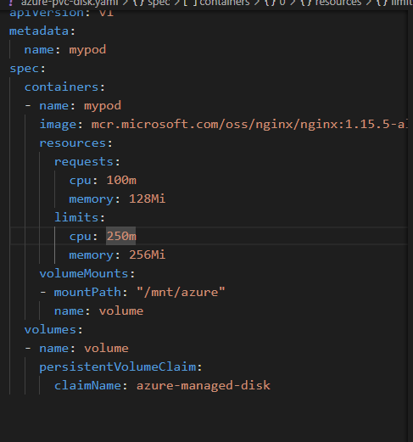  
9. Create the pod with kubectl apply -f azure-pvc-disk.yaml .

****10. Do a describe on the pod and check the volumes mounted.

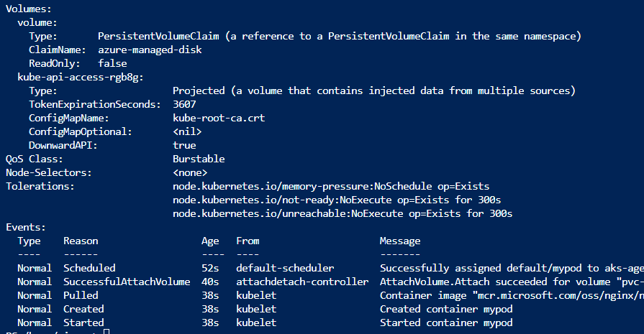  
11. Delete everything created under this practice including the storage class.

